STEPS ON HOW TO ACCESS THE MY.UNIZIK PORTAL AND GENERATE REMITA RRR NUMBER
- Visit the URL http://my.unizik.edu.ng and provide your UNIZIK student registration number as ‘Username’ with a default password of ‘password’ (this is ONLY for returning students). If you are a new student, note that your login information is already on your NAU e-clearance form. 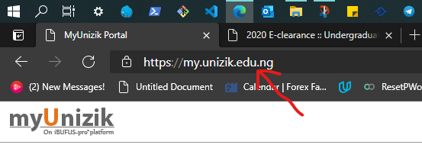 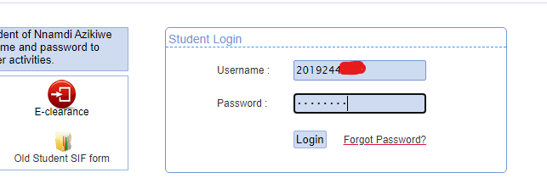
- On successful login, you will be required to change your default password to a secret password of your choice. 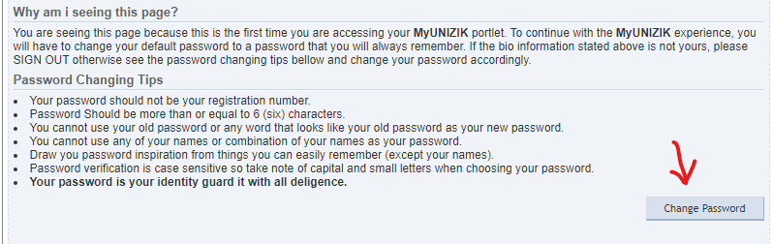 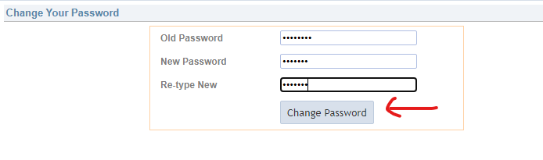
- Also update your phone number and religion and allow the process to complete. 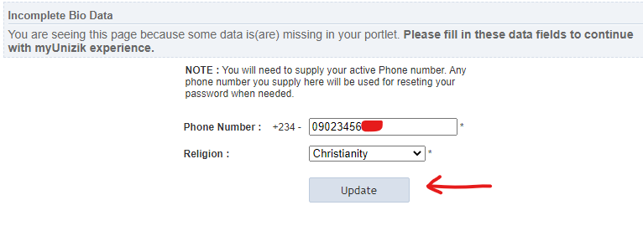
- On the Dashboard, click on the ‘myFees’ icon. 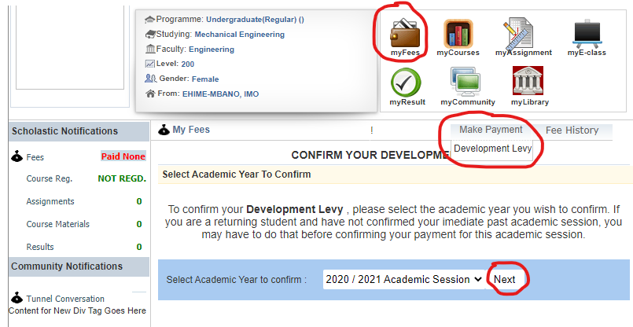
- Select the fee type you want to generate RRR for. For example, ‘Development Levy’.
- On the section, ‘Select Academic Session’, select the academic session for which you are generating the RRR. For example, ‘2020/2021 Academic Session’. Click on ‘Next’.
- Read the confirmation message and ensure that the information provided is accurate and the fee is correct. Click ‘Next’ if your data as reported on the portal is correct. Kindly note that if your data is incorrect at this point, PLEASE DO NOT CONTINUE the process. Write an official letter to Director MICTU (Software services) or send a ticket to support.unizik.edu.ng, attaching the necessary documents, or visit the MICTU office at the Administrative Block B for an update to your data.
- 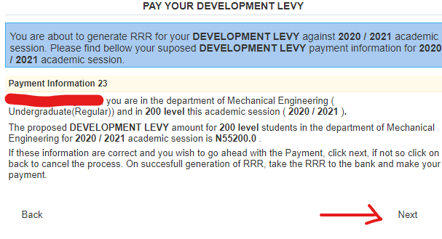
- In the next section, click on the ‘Process Payment’ button. Clicking on this button would redirect you to our internal page where your Remita invoice details would be displayed. Take note of the RRR provided and pay the fee using any available payment channel such as bank deposits or card payments. 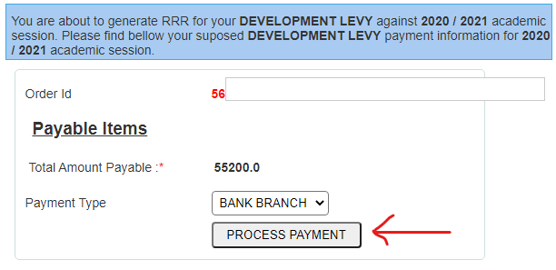 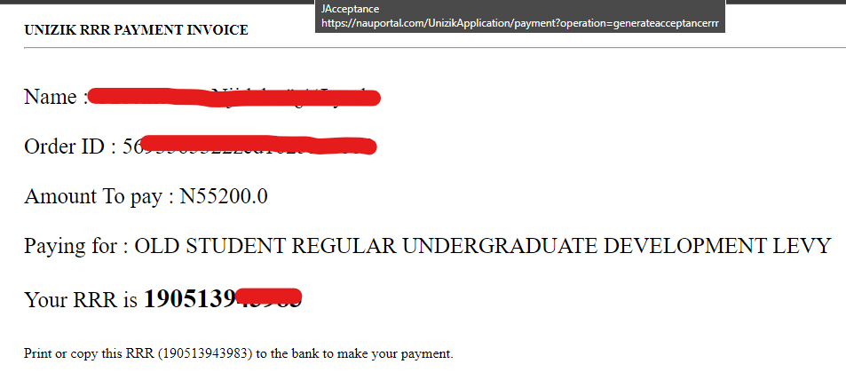
- When you have paid the Remita invoice and obtained a Remita receipt, your payment is confirmed automatically on your next login. However, if you need to re-confirm the RRR payment, login to your dashboard and insert the RRR number in the space provided and click on ‘Verify RRR’ button. 