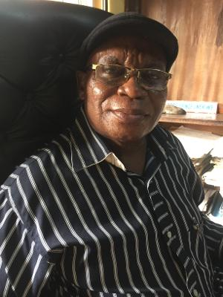 A PROFILE OF PROF. PRINCE UNEKWE
PROF. UNEKWE PRINCE is a Professor/Researcher with the Department of Pharmacology and Therapeutics, Faculty of Medicine, College of Health Sciences, Nnamdi Azikiwe University, Awka, Nnewi Campus, Nnewi, Nigeria. He is also a Consultant Pharmacologist with the Nnamdi Azikiwe University Teaching Hospital Nnewi Nigeria. He has all his degrees Bsc (1982). Msc (1984), and PhD (1987) in Pharmacology and Therapeutics, University of Ibadan, Ibadan, Nigeria. An experienced and accomplished teacher in Pharmacology and Therapeutics with more than 150 publications in peer reviewed Journals including some published chapters/text books in Pharmacology for both undergraduate and post graduate students. He has successfully supervised more than 78 Msc and 32 PhD candidates in Pharmacology. He also held many administrative positions in Nnamdi Azikiwe University and is one of the pioneer staff of the Faculty of Medicine. He was the chairman of first accreditation Task Force Committee of Faculty of Medicine of this our great University. The honours and awards of Prof Prince Unekwe include the following, Federal Government Scholar (1983-1984), University of Ibadan Senate Research Grant Award (1986), Nnamdi Azikiwe University Commendation Letter (1994), Nnamdi Azikiwe University Senate Research Grant Award (1995) and UNDP grant for studies on Anti-malaria drug research (1997). Chairman/ Secretary /Member of some Committees of the Faculty of Medicine and College of Health Sciences. He is an experienced External Examiner in Pharmacology in many medical and Pharmacy schools in both Nigeria and some West African Countries for both undergraduate and postgraduate students. Editor and member at Editorial Board of many Local and International Journals. Member of Society of African Journal of Editors (SAJE). Member of west African Society of Pharmacology (WASP), member of the foundation for African Development through international Biotechnology, member of Institute of Biology, London, member of American society for Pharmacology and Experimental Therapeutics (ASPET). Fellow of the institute of management specialist (FIMS), member of NUC instrument for institutional Accreditation Team and member of the Board of Management of NAUTH, Nnewi, Nigeria. Research interests include EthnoPharmacology, Cardiovascular Pharmacology, Smooth Muscle / ANS Pharmacology, Chemotherapy and Pharmacokinetics. Finally, he is happily married with children.

